

Recipes by Tonia Todman

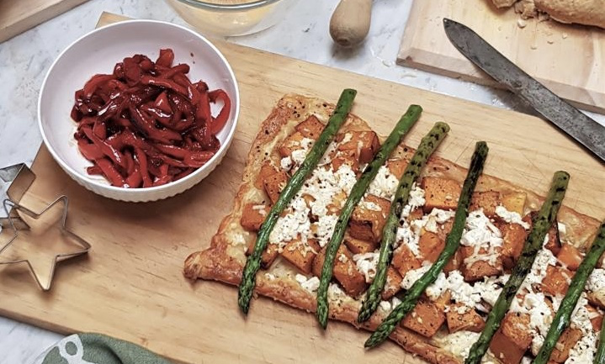

Slumped Capsicums

Ingredients:

- 1 large capsicum per person
- 4 level tablespoons brown sugar
- 4 level tablespoons balsamic vinegar
- 4 level tablespoons oil

Method:

Slice red capsicums into strips a little less than 1cm wide. Dispose of all seeds and as much white pith as possible. I allow one large capsicum per person. Quantities for the other ingredients are very flexible – but as a start, to four sliced capsicums add four level dessertspoons each of brown sugar, balsamic and olive oil to your dish.

Put these strips into a heavy-based lidded pan with brown sugar, balsamic vinegar and olive oil to taste – mix well. Place over very low heat with lid on and allow to cook for about one hour – checking often to stir. Capsicums should have 'slumped' and the liquid should be thickened, tangy and sweet once cooked.

Add more of any ingredient you feel is necessary while cooking, so taste the liquid a few times to check on flavour.

Capsicums cooked this way are delightful over pasta, served with BBQ'd meat, on sandwiches and are ideal with most roasted chicken dishes.

Will keep in a lidded container in the 'fridge for two weeks.

Copyright Tonia Todman
www.toniatodman.com

