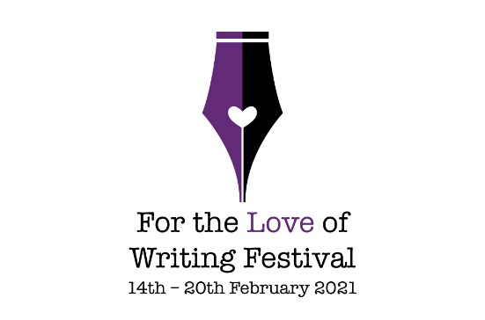
SATURDAY 20th FEBRUARY
DAILY SCHEDULE
TIME | EVENT
8.30am – 8.50am | Wake Up! Writers  Move those bodies and stretch. Feel invigorated and full of energy following this exercise class designed just for writers (all ages and abilities welcome)  Presenter: Hannah Johnson
10.00am | Morning Briefing  Find out what is in store for the day ahead. Details on the festival sessions and any festival announcements.  Presenter: Caroline Webber
10.30am – 11.30am | Inspiration: Writing for young people  Transferring the passion of writing for young people into a story involves serious commitment. It is about translating inspiration into words that inspire young people to think, create, explore, laugh, cry and engage. Discover the magic of picture books, advocate against bullying in children’s books, support campaigns such as literacy, unlock the hilarious humour of kids, and navigate the dramatic search for identity in young adult novels. Writing for young people is inspiring and a privilege/  Present: Susanne Gervay OAM
12.15pm – 1.15pm | Writing is NOT a lonely business  “Every writer I know has trouble writing.” – Joseph Heller  The Love of Writing is the start, but writing is trouble. It is very hard at times especially when alone. How do you translate that love of writing into the work you want to create? There is reading and writing in your private place. However writing needs company to support each other’s journey. Through the writing community, you can share the craft, editing, promotions, events, opportunities and the many aspects of being a writer. Hazel Edwards OAM and Susanne Gervay OAM share how relevant it is that writing is not a lonely business.  Presenters: Hazel Edwards OAM and  Susanne Gervay OAM
1.15pm | LOVE LETTER COMPETITION WINNERS ANNOUNCED AND LIVE DRAW FOR THE SUE SMETHURST 4-BOOK PACK.
2.00pm – 3.00pm | Words and Pictures: The illustrator’s perspective  Creating an illustrated book is a collaborative process combining the creative skills of two or more individuals from different disciplines – the wordsmith and the artist.  Successful collaborations produce amazing results; unsuccessful collaborations can cause pens and brushes to fly. So how does an illustrator express themselves creatively when responding to other people’s words? How do you ensure synergy? How do you unite to create a book that meets industry and consumer’s expectations?  Join artists and book illustrators Nettie Lodge, Jess Racklyeft, Kathryn Garland and Jack and Harry Beaumont to find out.
4.00pm – 5.00pm | For the Love of Biography  Jo’s biography of Jessie Traill was published by Australian Scholarly Publishing in early 2020. From the 10-year-old girl who first met Tom Roberts painting on the Ti-Tree lined shores of Port Phillip Bay, to a student of Frederick McCubbin and etchers John Mather and Frank Brangwyn, Jessie developed her skills as an artist. She interrupted her career to work as a voluntary nurse in France for 5 years in World War I, later raised funds, and revisited to war-torn Europe. She returned to become one of most accomplished Australian etchers of the twentieth century  Presenter: Jo Oliver
5.00pm – 5.15pm | Festival Closing  Hazel Edwards, OAM, Patron Society of Women Writers Victoria and Caroline Webber, President Society of Women Writers Victoria
6.45pm - 7.00pm | Bedtime Story  Join Kilisitina Sisifa and Fiona Mearon reading their own short stories.  Kilisitina will read Sing Me A Lullaby, her first published book for children. A dreamy lullaby picture book for sleepy, yet restless children.  Fiona will read Bolognese Days, the second in a series of whimsical tales of adventure and possibilities for children of all ages enjoy.  Enjoy a pre-recorded bedtime story to lull your little ones to sleep while you settle in for the evening session.
7.00pm – 8.00pm | FINALE  Difficult Women has been performing concerts in the Australian and International Art and Folk Festivals since its inception in 1993. Using the acting, narrating and singing skills of Lin Van Hek and the musical and arranging talents of multi-instrumentalist, Joe Dolce, Difficult Women brings to life on stage, both in concert and stage format, some of our most important and controversial women artists. Women who were labeled difficult in their day due to their willingness to go against the accepted norm for what it meant to be a female artist.  PLEASE NOTE: There is an additional charge for this event to see it live in person. Please go here to book: https://www.paypal.com/paypalme/difficultwomen  Tickets are $20 and limited to 15 seats.

